# (36) World Mapping-I

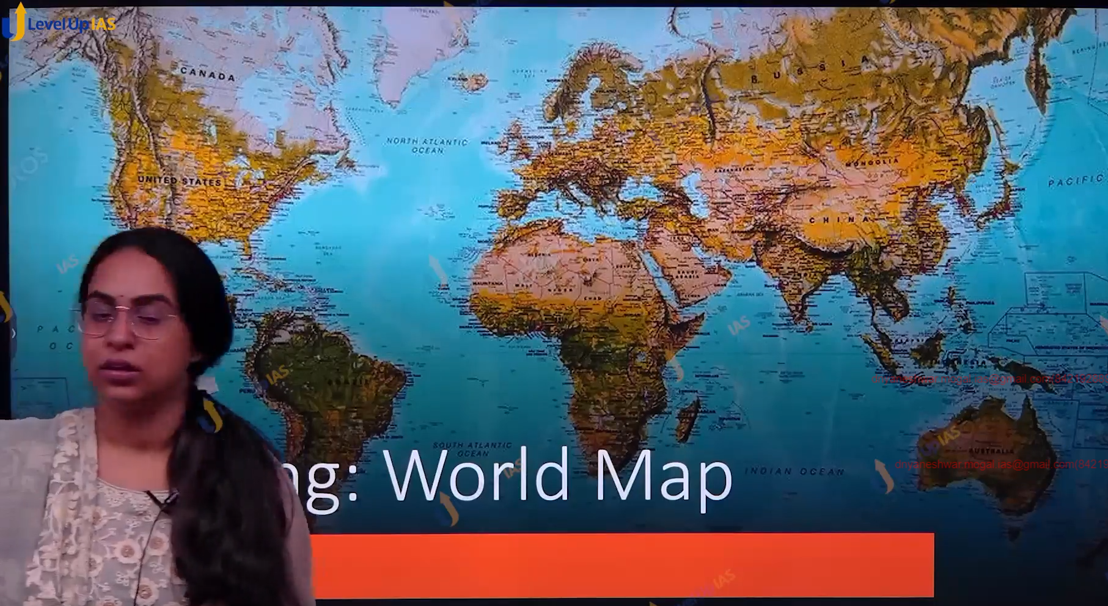

T:

1. It

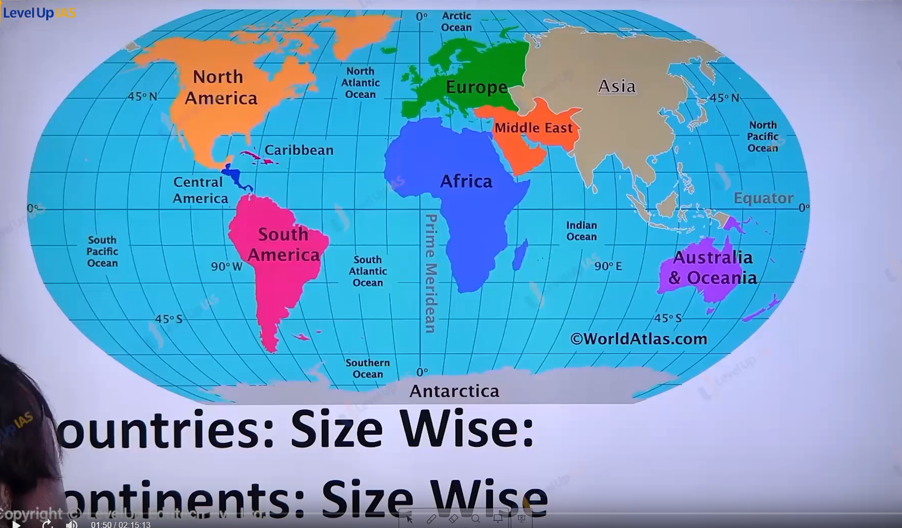

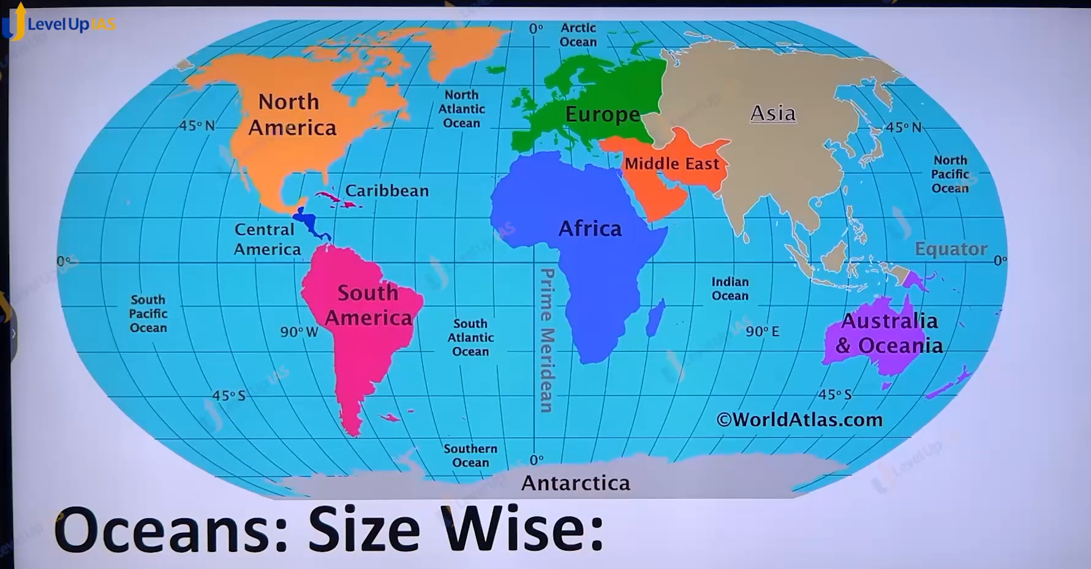

Some important basics of mapping

The largest country

1. Russia
2. Canada
3. China
4. Us
5. Brazil
6. Australia
7. India.

Continent size wise

1. Asia
2. Africa
3. North America
4. South America
5. Antarctica
6. Europe
7. Australia

Ocean size wise

1. Pacific
2. Atlantic
3. Indian
4. Southern
5. Artic.

Country through equator passes:

Zero-degree latitude

1. Ecuador
2. Colombia
3. Brazil
4. Gabon
5. DRC (democratic republic of Congo)
6. UGANDA
7. Kenya
8. Congo
9. Somalia
10. Kiribati
11. Indonesia
12. Maldives

: Places through which green which meridian passes.

1. England
2. France
3. Spain
4. Algeria
5. mail
6. Burkina Faso
7. Ghana
8. Antartica
9. Togo.

